**ECE 3457**

**Lab 1: MOSFET Current-Voltage Characteristics**

Ethan Hitchcock (1408202)

**Goal:**

Measure and characterize nMOS and pMOS IV curves.

**Task A:**

Measure and plot the *IV* curves of a CD4007 enhancement-type nMOS transistor. Determine the threshold voltage, Vt, and the conductivity parameter, K. Run PSPICE and show simulated device *iv.*

**Task B:**

Repeat Task A for a CD4007 enhancement pMOS.

**Theory:**

The CD4007 enhancement nMOS and pMOS transistors have gate, drain, and source pins. The transistor has the equations

$$I_{DS}=K_{n}^{'}\frac{W}{L}\left[\left(V_{GS}- V_{T}\right)V_{DS}- \frac{{V_{DS}}^{2}}{2}\right]$$

for when the transistor is operating in the triode region (VGS > VT and VDS ≤ VGS – VT) and

$$I_{DS}=\frac{1}{2}K_{n}^{'}\frac{W}{L}{\left(V_{GS}- V_{T}\right)}^{2}$$

for when the transistor is operating in the saturation region (VGS > VT and VDS > VGS – VT). As the transistor enters the saturation region, the ID curve will begin to plateau. This is because the equation for current through the drain and source pins is not dependent on VDS when the transistor is operating in the saturation region. By obtaining the nMOS and pMOS transistors’ iv curves for different VGS values, it becomes possible to derive the value of K where

$$K=\frac{1}{2}K_{n}^{'}\frac{W}{L}$$

We can calculate the value of K and VT by plotting the square root of IDS against VGS according to the linear equation

$$\sqrt{I_{DS}}= \sqrt{K}(V_{GS}-V_{T})$$

Where the square root of K is the slope and VT is the x-intercept.

**Experiment:**

**Task A: nMOS:**

The circuit was set up as below to test the iv characteristics of an enhancement nMOS.

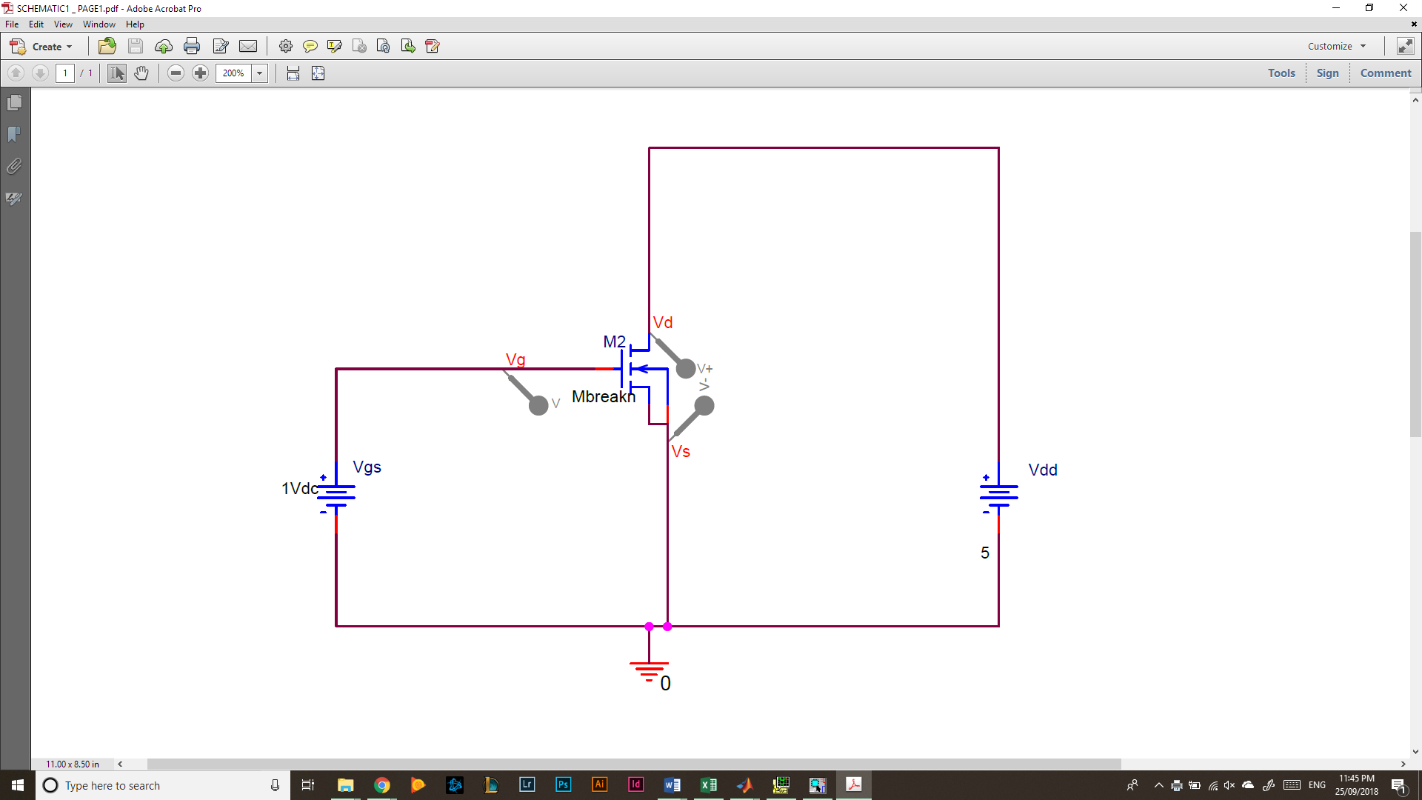  
*Figure 1: nMOS Test Circuit*

As in the above circuit, pin 3 was the gate voltage or VGS, pin 4 was the source voltage which was connected to ground, and pin 5 was the drain which was connected to VDS, or VDD according to Figure 1. Additionally, pin 7 (VSS) was connected to ground for proper operation of the chip. First VGS was set to 0 and then ID measured (the current through VD and VS) for VDD from 0[V] to 5[V] in 0.5[V] increments. Then VGS was incremented by 0.5[V] and the test for VDD and ID repeated. This process was repeated for VGS values from 0[V] to 5[V]. The following data was obtained for the nMOS transistor iv curves (tabular data at end of report).

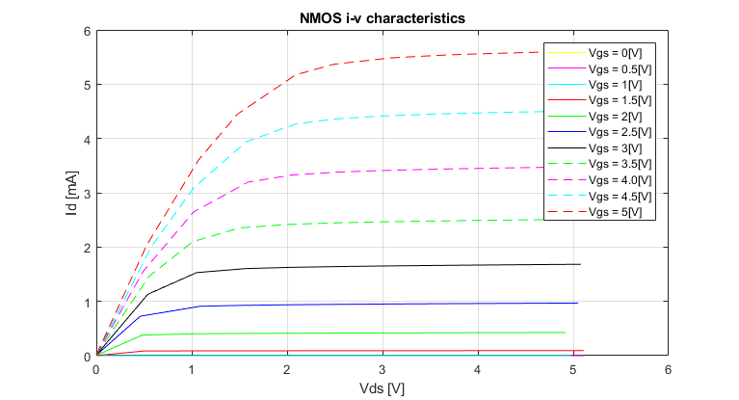  
*Figure 2: nMOS iv Characteristic Curves*

**Task B: pMOS:**

The circuit was set up as below for the pMOS circuit testing.

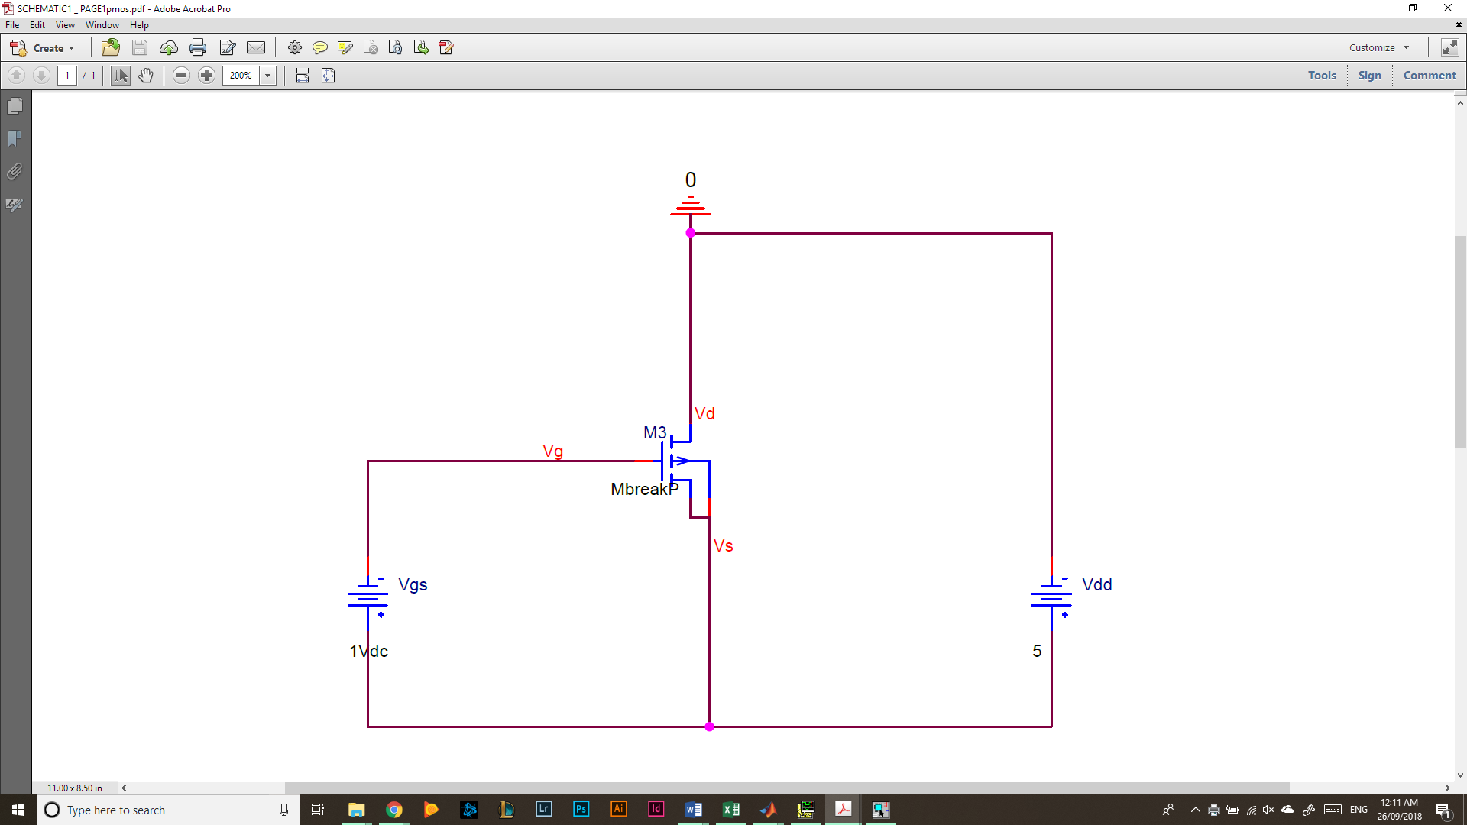  
*Figure 3: pMOS Test Circuit*

Notice the voltage sources have been inverted from the previous test circuit. This was because the pMOS requires negative voltages for operation. Additionally, the ground was moved to the drain pin or pin 14 on the CD4007 chip. This was to ensure the chip functioned correctly as pin 14 was VDD and needed to be supplied the most positive voltage in the circuit to ensure proper operation. The source pin or pin 13 was connected to the positive terminals of VDD and VGS, and the gate pin or pin 3 was connected to the negative terminal of VGS. The voltages were set the same way as in testing for the nMOS and the following iv graph was obtained.

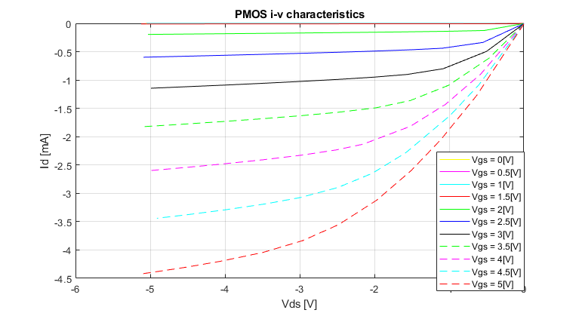  
*Figure 4: pMOS iv Characteristic Curves*

Values for K and VT can be found using this data. By selecting the current at which each transistor first enters saturation, or begins to plateau, a graph of the square root of ID vs VGS can be constructed. Currents that are consistently 0 across a VGS have been omitted.

*Figure 5: VGS vs ID1/2 For the nMOS Transistor*

The slope of this line is 0.018515 which is equivalent to the square root of Kn. Therefore, the value of Kn is 342.8[μA/V2] and the value of VT is obtained by setting y to 0 and solving for x. Therefore, VT is equal to 0.91[V].

*Figure 6: VGS vs ID1/2 For the pMOS Transistor*

The slope of this line is 0.018025 which is equivalent to the square root of Kp. Therefore, the value of Kp is 324.9[μA/V2] and the value of VT is obtained by setting y to 0 and solving for x. Therefore, VT is equal to 1.30 [V].

**Simulation:**

The values of K and VT calculated above can be used in the simulations using PSPICE. The circuit schematics used for PSPICE are identical to those in Figure 1 and Figure 2 for nMOS and pMOS simulations respectively.

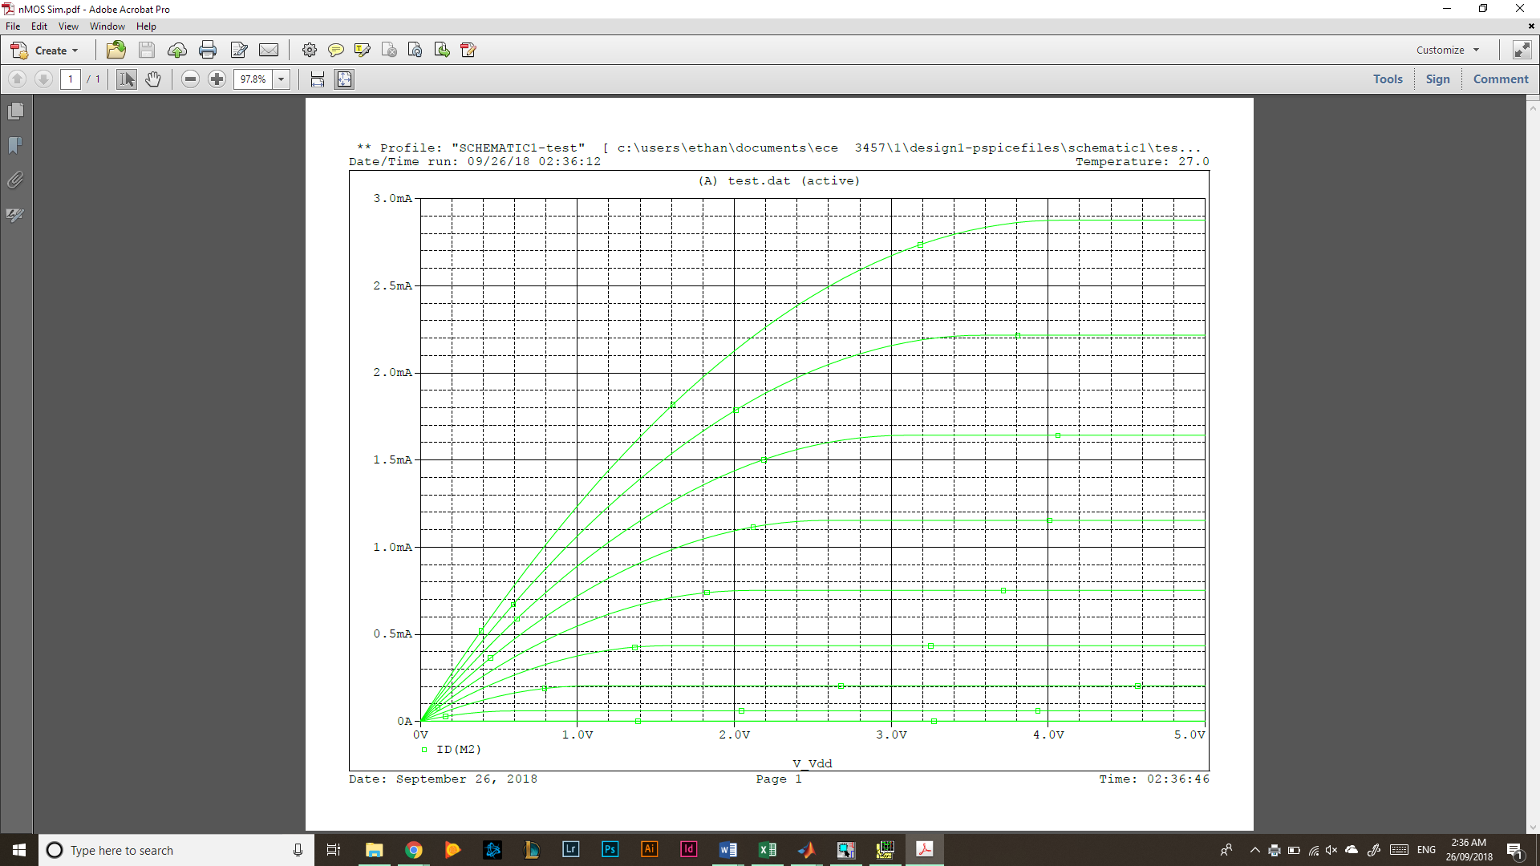  
*Figure 7: nMOS Simulation iv Characteristic Curves*

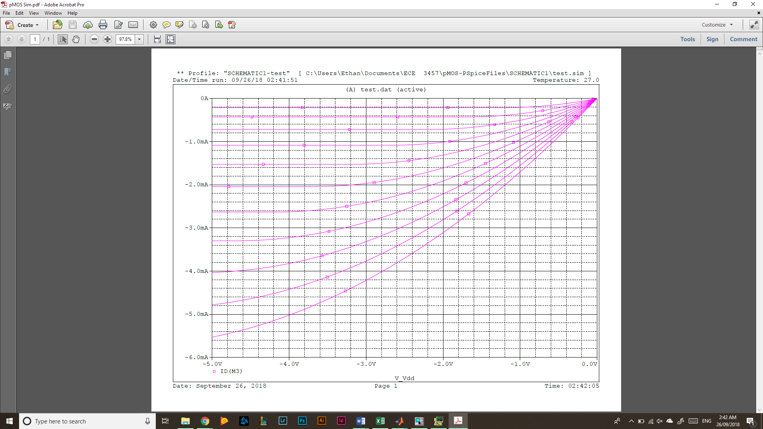 *Figure 8: pMOS Simulation iv Characteristic Curves*

**Analysis:**

While the general shapes of the plots remained the same between the experiment and the simulation, the values for ID varied drastically for increasing VGS. This may be due to inaccuracies when calculating VT and K. The values of ID and VGS were chosen arbitrarily after it seemed the iv characteristic graphs had begun to plateau. This is the most likely source of error in the calculations of K and VT. The reason for the inconsistency in selecting values is that the graph did not always plateau like expected, this is easily seen in Figure 4 where the larger magnitude values of VGS do not taper to a constant ID. Additionally, data collection extending past 5[V] for VDS while testing and using smaller increments would have resulted in more accurate iv characteristic curves for the nMOS and pMOS transistors. In theory, an ideal transistor will have a drain current which plateaus when VDS > VGS – VT. In practice, the current will still creep upwards after this point making it difficult to accurately measure K and VT.

|  |  |  |  |  |  |  |  |  |  |  |  |  |
| --- | --- | --- | --- | --- | --- | --- | --- | --- | --- | --- | --- | --- |
| vGS [V] | **nMOS** | **Tabulated** | **Data** |  |  |  |  |  |  |  |  |  |
| 0 | vDS [V] | 0 | 0.51 | 1.09 | 1.59 | 2.08 | 2.48 | 2.96 | 3.49 | 4 | 4.55 | 5.03 |
|  | iD [mA] | 0 | 0 | 0 | 0 | 0 | 0 | 0 | 0 | 0 | 0 | 0 |
|  |  |  |  |  |  |  |  |  |  |  |  |  |
| 0.5 | vDS (V) | 0 | 0.5 | 1 | 1.48 | 2.03 | 2.56 | 2.99 | 3.44 | 4.04 | 4.52 | 5.11 |
|  | iD (mA) | 0 | 0 | 0 | 0 | 0 | 0 | 0 | 0 | 0 | 0 | 0 |
|  |  |  |  |  |  |  |  |  |  |  |  |  |
| 1 | vDS (V) | 0 | 0.49 | 1.09 | 1.64 | 2.01 | 2.64 | 3.1 | 3.56 | 4.02 | 4.51 | 4.98 |
|  | iD (mA) | 0 | 0.001 | 0.0011 | 0.0011 | 0.0011 | 0.0011 | 0.0011 | 0.0011 | 0.0011 | 0.0011 | 0.0011 |
|  |  |  |  |  |  |  |  |  |  |  |  |  |
| 1.5 | vDS (V) | 0 | 0.5 | 1.03 | 1.47 | 1.98 | 2.47 | 3.1 | 3.65 | 4.05 | 4.54 | 5.11 |
|  | iD (mA) | 0.0026 | 0.0861 | 0.0882 | 0.0891 | 0.0898 | 0.0906 | 0.0913 | 0.0919 | 0.0923 | 0.0927 | 0.0932 |
|  |  |  |  |  |  |  |  |  |  |  |  |  |
| 2 | vDS (V) | 0 | 0.48 | 1.02 | 1.58 | 2.07 | 2.48 | 3.07 | 3.63 | 4.09 | 4.53 | 4.92 |
|  | iD (mA) | 0.0066 | 0.3781 | 0.4031 | 0.4095 | 0.4133 | 0.416 | 0.419 | 0.4216 | 0.4235 | 0.4251 | 0.4265 |
|  |  |  |  |  |  |  |  |  |  |  |  |  |
| 2.5 | vDS (V) | 0 | 0.46 | 1.09 | 1.53 | 2.09 | 2.59 | 3.09 | 3.58 | 4.06 | 4.55 | 5.05 |
|  | iD (mA) | 0.0094 | 0.7257 | 0.91 | 0.9265 | 0.9383 | 0.9456 | 0.9515 | 0.9564 | 0.9607 | 0.9649 | 0.9687 |
|  |  |  |  |  |  |  |  |  |  |  |  |  |
| 3 | vDS (V) | 0 | 0.54 | 1.05 | 1.57 | 2.05 | 2.51 | 3.05 | 3.48 | 4.03 | 4.47 | 5.08 |
|  | iD (mA) | 0.0123 | 1.1308 | 1.5297 | 1.604 | 1.6266 | 1.6402 | 1.6523 | 1.6602 | 1.669 | 1.6751 | 1.6829 |
|  |  |  |  |  |  |  |  |  |  |  |  |  |
| 3.5 | vDS (V) | 0 | 0.55 | 1.01 | 1.5 | 1.99 | 2.58 | 3.01 | 3.58 | 4.03 | 4.57 | 5.01 |
|  | iD (mA) | 0.0142 | 1.457 | 2.0986 | 2.3515 | 2.416 | 2.449 | 2.4648 | 2.4808 | 2.4915 | 2.5022 | 2.5101 |
|  |  |  |  |  |  |  |  |  |  |  |  |  |
| 4 | vDS (V) | 0 | 0.49 | 1.02 | 1.59 | 2.05 | 2.51 | 3.03 | 3.51 | 4.04 | 4.52 | 4.99 |
|  | iD (mA) | 0.0165 | 1.5504 | 2.6471 | 3.1959 | 3.3268 | 3.3792 | 3.4115 | 3.4322 | 3.4504 | 3.4637 | 3.4752 |
|  |  |  |  |  |  |  |  |  |  |  |  |  |
| 4.5 | vDS (V) | 0 | 0.58 | 1.02 | 1.57 | 2.09 | 2.51 | 3.06 | 3.58 | 4.06 | 4.49 | 5.13 |
|  | iD (mA) | 0.0181 | 2.0178 | 3.0908 | 3.9378 | 4.2673 | 4.361 | 4.419 | 4.4515 | 4.4735 | 4.4884 | 4.5085 |
|  |  |  |  |  |  |  |  |  |  |  |  |  |
| 5 | vDS (V) | 0 | 0.53 | 1.07 | 1.48 | 2.09 | 2.49 | 3.09 | 3.64 | 4.04 | 4.51 | 4.99 |
|  | iD (mA) | 0.015 | 2.043 | 3.6003 | 4.449 | 5.1728 | 5.3674 | 5.4843 | 5.5355 | 5.56 | 5.5832 | 5.6018 |

|  |  |  |  |  |  |  |  |  |  |  |  |  |
| --- | --- | --- | --- | --- | --- | --- | --- | --- | --- | --- | --- | --- |
| vGS [V] | **pMOS** | **Tabulated** | **Data** |  |  |  |  |  |  |  |  |  |
| 0 | vDS [-V] | 0 | 0.49 | 1.06 | 1.56 | 2.01 | 2.51 | 3.01 | 3.51 | 4.11 | 4.54 | 5.06 |
|  | iD [-mA] | 0 | 0 | 0 | 0 | 0 | 0 | 0 | 0 | 0 | 0 | 0 |
|  |  |  |  |  |  |  |  |  |  |  |  |  |
| 0.5 | vDS [-V] | 0 | 0.48 | 1.08 | 1.5 | 2.13 | 2.45 | 2.98 | 3.51 | 4.17 | 4.49 | 5.05 |
|  | iD [-mA] | 0 | 0 | 0 | 0 | 0 | 0 | 0 | 0 | 0 | 0 | 0 |
|  |  |  |  |  |  |  |  |  |  |  |  |  |
| 1 | vDS [-V] | 0 | 0.45 | 1.14 | 1.47 | 2.04 | 2.47 | 3.18 | 3.47 | 4.08 | 4.52 | 5.05 |
|  | iD [-mA] | 0 | 0 | 0 | 0 | 0 | 0 | 0 | 0 | 0 | 0 | 0 |
|  |  |  |  |  |  |  |  |  |  |  |  |  |
| 1.5 | vDS [-V] | 0 | 0.54 | 1.01 | 1.55 | 2.1 | 2.47 | 3.01 | 3.5 | 4.02 | 4.52 | 5.12 |
|  | iD [-mA] | 0.0003 | 0.0056 | 0.006 | 0.0066 | 0.0071 | 0.0075 | 0.0079 | 0.0084 | 0.0089 | 0.0094 | 0.0099 |
|  |  |  |  |  |  |  |  |  |  |  |  |  |
| 2 | vDS [-V] | 0 | 0.53 | 1.07 | 1.66 | 2.08 | 2.47 | 3.03 | 3.53 | 4.09 | 4.56 | 5.03 |
|  | iD [-mA] | 0.0022 | 0.126 | 0.1407 | 0.151 | 0.1573 | 0.1627 | 0.1702 | 0.1765 | 0.1833 | 0.189 | 0.1946 |
|  |  |  |  |  |  |  |  |  |  |  |  |  |
| 2.5 | vDS [-V] | 0 | 0.55 | 1.09 | 1.49 | 2.1 | 2.51 | 2.97 | 3.5 | 4.07 | 4.48 | 5.09 |
|  | iD [-mA] | 0.0039 | 0.337 | 0.4385 | 0.4649 | 0.4936 | 0.5106 | 0.528 | 0.5465 | 0.5653 | 0.5785 | 0.5972 |
|  |  |  |  |  |  |  |  |  |  |  |  |  |
| 3 | vDS [-V] | 0 | 0.5 | 1.08 | 1.56 | 2.01 | 2.48 | 3.08 | 3.53 | 4.01 | 4.47 | 4.99 |
|  | iD [-mA] | 0.0054 | 0.4948 | 0.8004 | 0.901 | 0.9496 | 0.9885 | 1.031 | 1.0602 | 1.0896 | 1.1155 | 1.1446 |
|  |  |  |  |  |  |  |  |  |  |  |  |  |
| 3.5 | vDS [-V] | 0 | 0.47 | 1.01 | 1.52 | 1.98 | 2.49 | 2.97 | 3.53 | 3.98 | 4.57 | 5.1 |
|  | iD [-mA] | 0.0067 | 0.6173 | 1.094 | 1.3621 | 1.4906 | 1.5696 | 1.628 | 1.6858 | 1.7284 | 1.7803 | 1.8236 |
|  |  |  |  |  |  |  |  |  |  |  |  |  |
| 4 | vDS [-V] | 0 | 0.58 | 1.05 | 1.52 | 2.15 | 2.5 | 2.95 | 3.5 | 4.02 | 4.41 | 4.99 |
|  | iD [-mA] | 0.0079 | 0.8979 | 1.4301 | 1.8176 | 2.1315 | 2.231 | 2.322 | 2.4092 | 2.4799 | 2.5296 | 2.5976 |
|  |  |  |  |  |  |  |  |  |  |  |  |  |
| 4.5 | vDS [-V] | 0 | 0.6 | 0.99 | 1.58 | 2.03 | 2.49 | 2.99 | 3.44 | 4 | 4.52 | 4.91 |
|  | iD [-mA] | 0.009 | 1.0813 | 1.6286 | 2.283 | 2.6475 | 2.8977 | 3.0734 | 3.1826 | 3.2918 | 3.38 | 3.44 |
|  |  |  |  |  |  |  |  |  |  |  |  |  |
| 5 | vDS [-V] | 0 | 0.63 | 1.11 | 1.51 | 1.97 | 2.48 | 2.96 | 3.5 | 4.06 | 4.54 | 5.1 |
|  | iD [-mA] | 0.01 | 1.2702 | 2.0499 | 2.6003 | 3.1212 | 3.553 | 3.8348 | 4.0465 | 4.1992 | 4.3087 | 4.4191 |